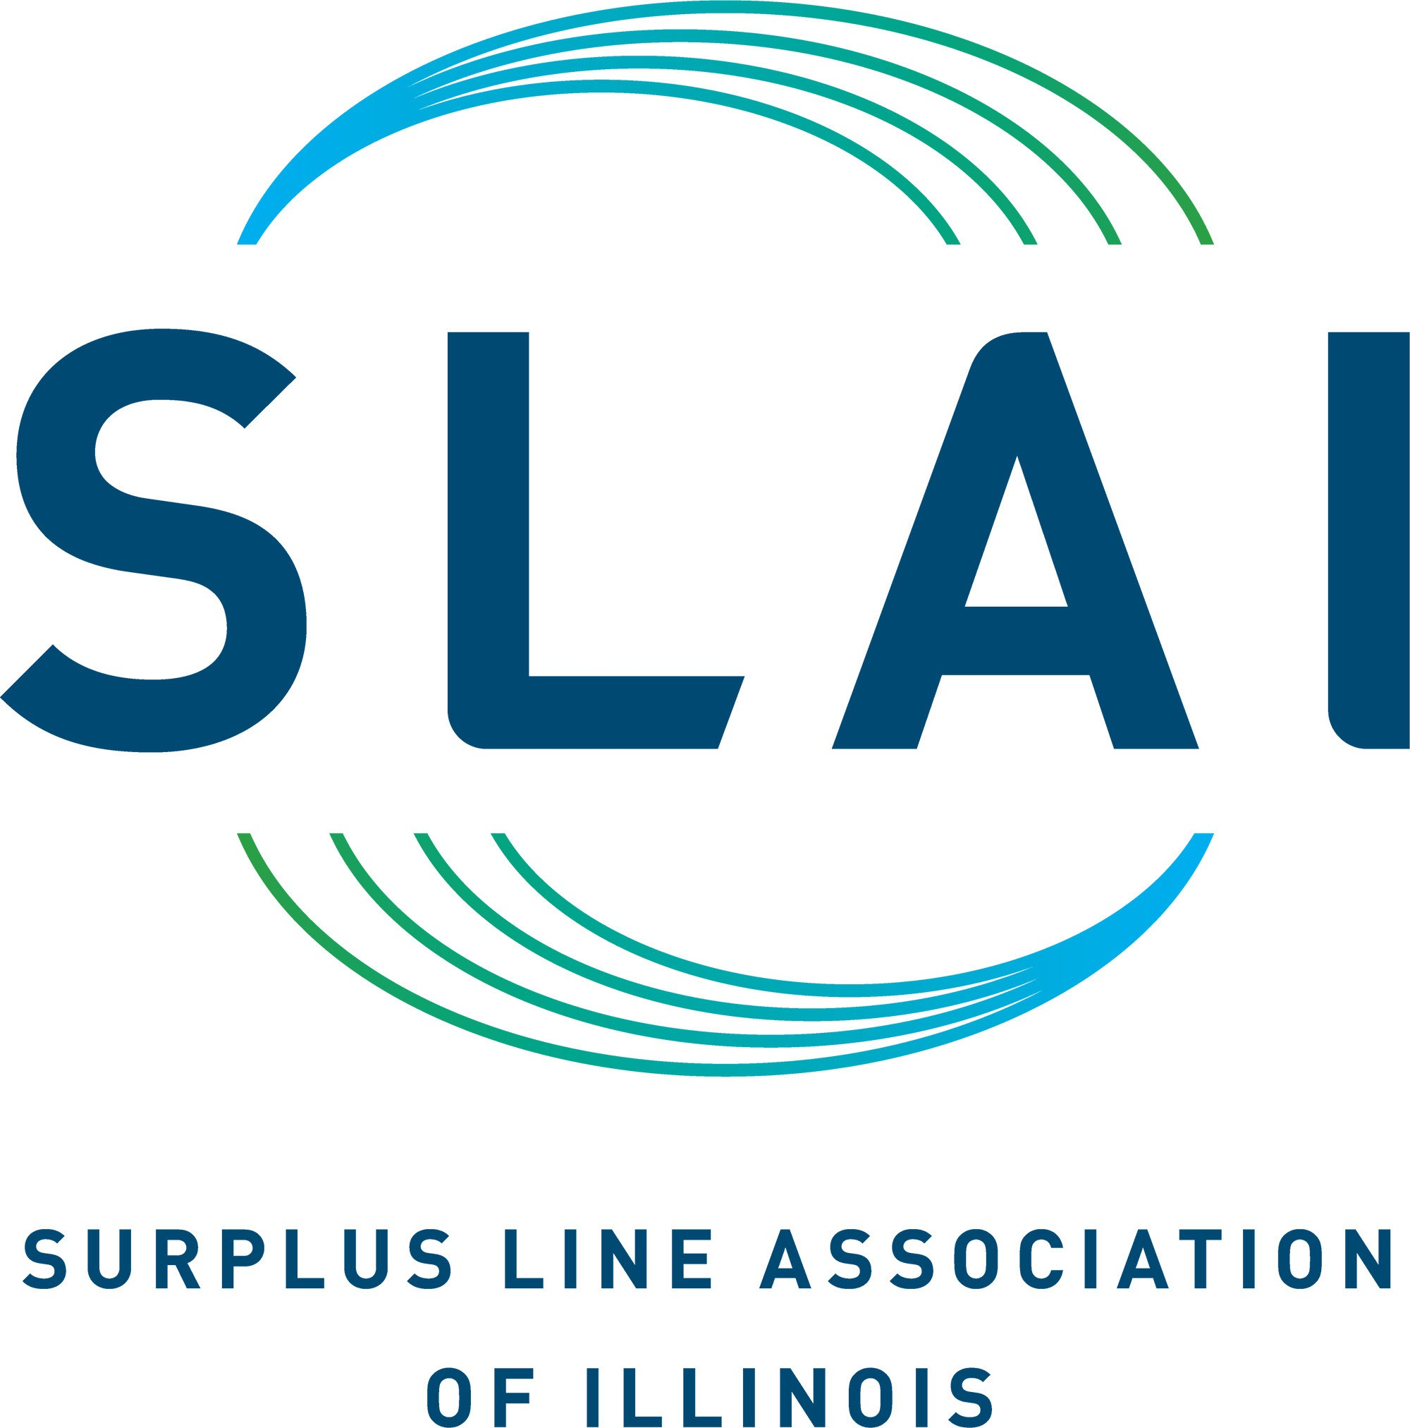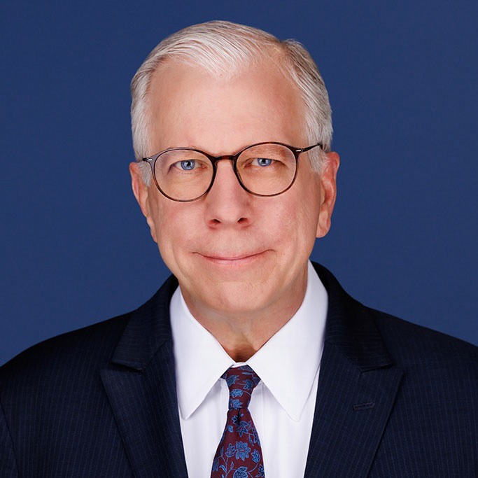
222 S. Riverside Plaza Suite 2220
Chicago, IL 60606

312.263.1993
www.slai.org
David L. Ocasek
Chief Executive Oﬃcer

Richard J. Dunlap
Director of Finance & Administration

David L. Ocasek
Chief Executive Oﬃcer, SLAI

David Ocasek is Chief Executive Officer of the Surplus Line Association of Illinois, a non-profit association created by public statute to act as a liaison between the Illinois Department of Insurance and surplus line producers and to provide marketplace data, education and compliance support.
Mr. Ocasek joined the Association in 1991 and became CEO in 1998. He is responsible for the development and implementation of the overall strategic goals of the Association with a focus on technology, education and regulatory affairs. During his tenure, he has guided the Association through major business model and regulatory changes, as well as growth in premium and processing volume in excess of 1800%.
He teaches an accredited Illinois continuing education course on surplus line insurance and has been an editor and contributor to multiple editions of the American Bar Association’s Annotations to Surplus Lines Statutes book. He is a recipient of the Dana Roehrig Award for his many years of service on the Legislative Committee of the Wholesale and Specialty Insurance Association.
David serves on the advisory board of the Katie School of Insurance and Risk Management at Illinois State University, and on the board of directors for the Insurance Regulator Education Foundation. He has also been an active participant and fundraiser for Envision Unlimited, serving people with disabilities, and the Pediatric Brain Tumor Foundation.
Prior to joining the Association, Mr. Ocasek held positions with Dallas-based GolfCorp, American Medical International in Los Angeles, The Chicago Sting Soccer Team, and Playboy Enterprises where he began his career after attending Yale University. He is a native of the Chicago area.

Surplus Line Association of Illinois — Updated August 2026

